There is a local peak in the crisis itself

We are going to use two indices

Firstly we’re going to be able to discretely look through the dates that we have chosen

And secondly we are going to use the map to select the specific data. That data could show locally

The map will have circles to show the number of cases and the red opacity of the circles would help show the severity

Map on the left and other graphs on the right

Pie chart for fatalities in the region

Line for the accidents over time

Statics on the left of the info part

Horizontal bar graphs which show local vs. global data

* Number of deaths
* Number of accidents
  + Number of police involvement

On the left of the bar graphs, we will have that data over time. Inspiration

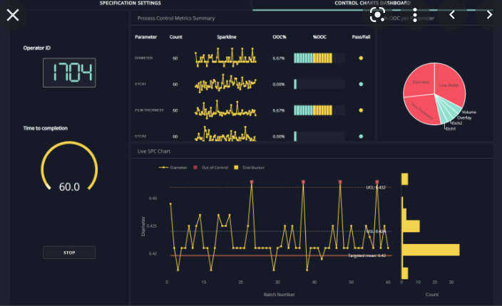

Imran will combine the dataset and create the GeoPandas Visualization for the map and the given aspects

Adam will write about the stuff about the visualizations till Friday and after Friday, he will look into the using Dash to create pie chart

Denis will create the bar graphs with the plot graph

Bora will create the line graph and

Domain task:

* User: R&S UK
* Task: “We want to analyze and understand the effects of the financial crisis on the road infrastructure of the time and how we can improve such if improvement is required. To better specify, we could also help focus on areas which have worsened due to the financial crisis to see if we have fixed those areas. Before some areas were good, crisis caused all areas to fail, after crisis some areas did not fully recover. We want to identify those areas. “

Task Abstraction:

* Compare Trends
* Browse extremes

Data Categorization:

* Two indices used to browse
  + Ordinal and discrete time sections
  + Geometric selection of data through the map itself
* Types of graphs
  + Geometrical map graph of the UK
    - Circles around areas show the number of accidents
    - The red opacity of the circles indicates the severity of the crash
    - Used for discovering features/outliers
    - Marks are areas
    - Channels are color, size, and position
  + Pie chart which compares severity of crashes
    - Severity ranges from nothing, to light bruises, to serious injuries, to fatal
    - Will use the color theme which was previously specified
    - Used to lookup/highlight extremes
    - Marks are areas
    - Channels are colors
  + Line graph will show the number of accidents over the relative amount of time selected
    - Peak will be highlighted with a dot if possible.
    - Used to compare trends
    - Marks are lines
    - Channels are positions
  + Horizontal bar graph will show the below attributes over the local and global values. This means that the graph will focus solely based on area that has been selected (local) compared to the global values over the entire selected time period.
    - Number of deaths
    - Number of accidents
    - Number of police involvement
    - Accompanying point graphs will be shown on the left side
    - Used to compare distributions
    - Marks are the volume of area of the bars themselves
    - Channels are the size of the bar
  + A general information panel will be presented on the left side of the information panel. It will only display the number of accidents, and the average of the severity of the accidents
    - Used to present features